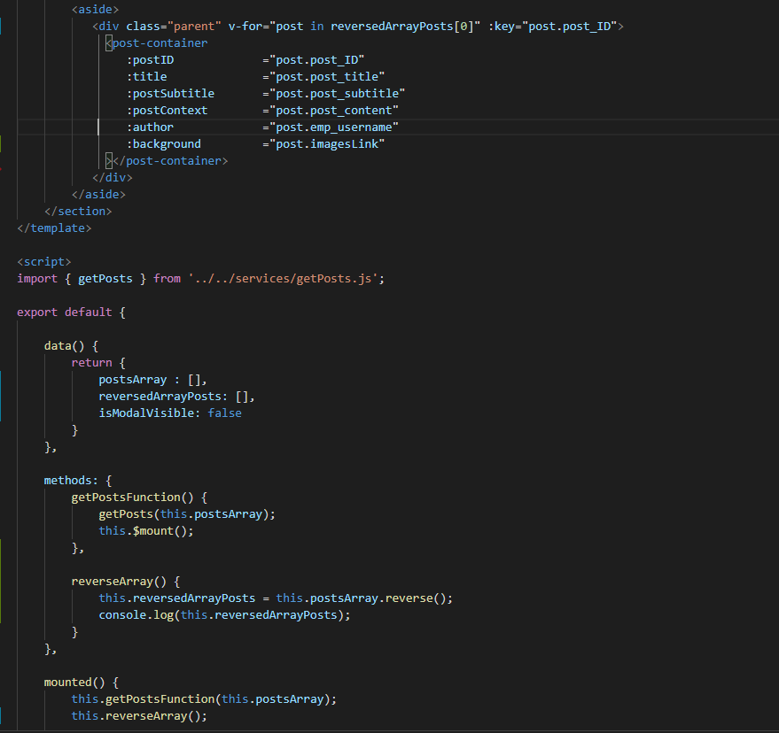

Good evening, morning. I managed to make the first added post to be displayed on the top of the page. In order to do this, I reversed the array where the posts objects was located. After reversing, I just replaced the array used for the loop with the new reversedArrayPosts.

Now, every posts can be displayed on the top of the page.

GitHub repo

https://github.com/ddmihai/Grupomania-Vue

Is possible to let me know about a decision?

Thanks, Daniel.